**Lab 6**

**Write a Rule Base System in Python for the following rule systems:**

1. **Weather Forecasting**

Rule 1: If sky is cloudy and there is no wind, then it might rain.

Rule 2: If temperature is below 0°C and the sky is clear, then it might snow.

Rule 3:If temperature is above 30°C and there is no wind, then it might be a hot day.

Rule 4: If sky is clear and there is wind, then it might be a pleasant day.

**Code:**

def weather_forecast():

    sky = input("Enter the sky condition (cloudy/clear): ")

    temperature = float(input("Enter the temperature in °C: "))

    wind = input("Enter the wind condition (none/some): ")

    if sky == "cloudy" and wind == "none":

        return "It might rain."

    elif temperature < 0 and sky == "clear":

        return "It might snow."

    elif temperature > 30 and wind == "none":

        return "It might be a hot day."

    elif sky == "clear" and wind == "some":

        return "It might be a pleasant day."

    else:

        return "Weather conditions are not covered by the rules."

forecast_result = weather_forecast()

print(forecast_result)

**Output:**

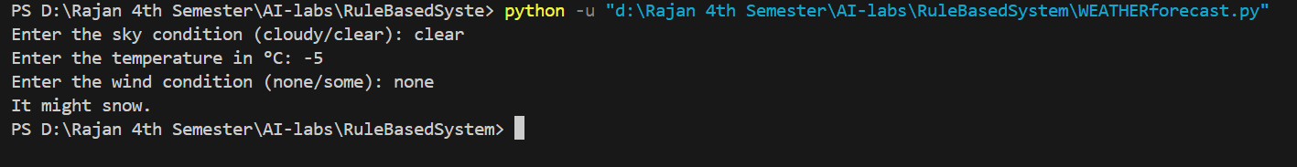

1. **Eligibility for a Loan**

Rule 1:If applicant's age is between 18 and 65 and they have a stable income, then

they are eligible for a loan.

Rule 2:If applicant has a credit score above 700, then they are eligible for a loan.

Rule 3:If applicant has a criminal record, then they are not eligible for a loan.

Rule 4:If applicant has defaulted on a loan before, then they are not eligible for

a loan.

**Code:**

def check_loan_eligibility():

    age = int(input("Enter the applicant's age: ").strip())

    stable_income = input("Does the applicant have a stable income? (yes/no): ").strip().lower()

    credit_score = int(input("Enter the applicant's credit score: ").strip())

    criminal_record = input("Does the applicant have a criminal record? (yes/no): ").strip().lower()

    loan_default = input("Has the applicant defaulted on a loan before? (yes/no): ").strip().lower()

    if criminal_record == "yes":

        return "The applicant is not eligible for a loan."

    elif loan_default == "yes":

        return "The applicant is not eligible for a loan."

    elif 18 <= age <= 65 and stable_income == "yes":

        return "The applicant is eligible for a loan."

    elif credit_score > 700:

        return "The applicant is eligible for a loan."

    else:

        return "The applicant is not eligible for a loan."

eligibility_result = check_loan_eligibility()

print(eligibility_result)

**Output:**

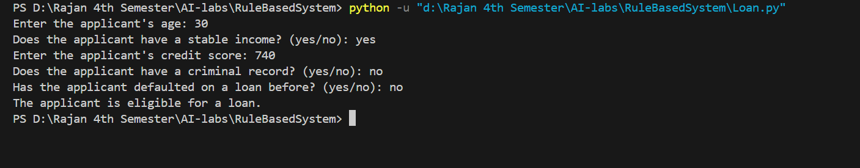

1. **Simple Decision Making**

Rule 1: If the time is between 6 AM and 8 AM and it's a weekday, then it's timeto go to work.

Rule 2: If the time is between 12 PM and 1 PM, then it's time for lunch.

Rule 3: If the time is between 9 PM and 10 PM, then it's time to go to bed.

Rule 4: If it's the weekend and the weather is sunny, then go for a walk.

**Code:**

def decision_making():

    time = float(input("Enter the current time : ").strip())

    weekday = input("Is it a weekday? (yes/no): ").strip().lower()

    weather = input("What is the weather like? (sunny/rainy): ").strip().lower()

    if 6 <= time <= 8 and weekday == "yes":

        return "It's time to go to work."

    elif 12 <= time <= 13:

        return "It's time for lunch."

    elif 21 <= time <= 22:

        return "It's time to go to bed."

    elif weekday == "no" and weather == "sunny":

        return "Go for a walk."

    else:

        return "No specific action for this time."

decision = decision_making()

print(decision)

**Output:**

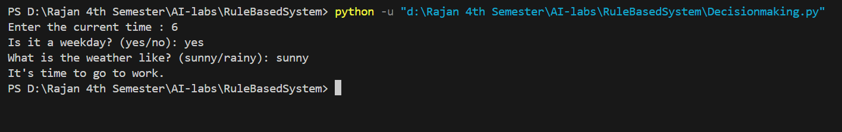

1. **Traffic Light Control**

Rule 1: If the light is red, then cars must stop.

Rule 2: If the light is green, then cars can go.

Rule 3: If the light is yellow, then cars must slow down and prepare to stop.

Rule 4: If the pedestrian button is pressed, then the light will turn red after a short delay.

**Code:**

def traffic_light_control():

    light_color = input("Enter the current traffic light color (red/green/yellow): ").strip().lower()

    pedestrian_button_pressed = input("Has the pedestrian button been pressed? (yes/no): ").strip().lower()

    if light_color == "red":

        return "Cars must stop."

    elif light_color == "green":

        return "Cars can go."

    elif light_color == "yellow":

        return "Cars must slow down and prepare to stop."

    elif pedestrian_button_pressed == "yes":

        return "The light will turn red after a short delay."

    else:

        return "Invalid input."

traffic_action = traffic_light_control()

print(traffic_action)

**Output:**

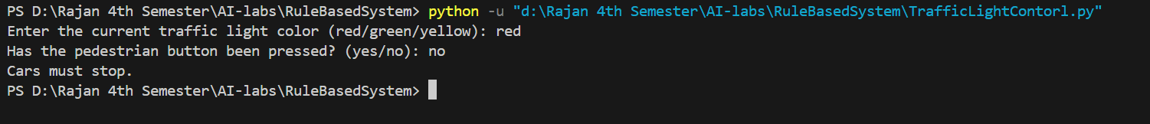

**5.Smart Home Automation**

Rule 1: If the temperature is below 18°C, then turn on the heater.

Rule 2: If the temperature is above 25°C, then turn on the air conditioner.

Rule 3: If it is dark outside and someone is at home, then turn on the lights.

Rule 4: If the security system is armed and a door is opened, then sound the alarm.

**Code:**

def smart_home_automation():

    temperature = float(input("Enter the current temperature in °C: ").strip())

    is_dark = input("Is it dark outside? (yes/no): ").strip().lower()

    someone_at_home = input("Is someone at home? (yes/no): ").strip().lower()

    security_armed = input("Is the security system armed? (yes/no): ").strip().lower()

    door_opened = input("Is a door opened? (yes/no): ").strip().lower()

    # Rule 1: Temperature control

    if temperature < 18:

        print("Turn on the heater.")

    # Rule 2: Temperature control

    if temperature > 25:

        print("Turn on the air conditioner.")

    # Rule 3: Lighting control

    if is_dark == "yes" and someone_at_home == "yes":

        print("Turn on the lights.")

    # Rule 4: Security system

    if security_armed == "yes" and door_opened == "yes":

        print("Sound the alarm.")

smart_home_automation()

**Output:**

